Gear Cars: Need For Speed
Made by: Samuel Hudon
Heritage Regional High School

Goal:
To make a car that can go as fast as possible over a 3-meter distance.
Materials:
- Rubber Stoppers
- Nylon Sleeves
- 3 Types of gears: Small 15 teeth, Medium 45 teeth and Large 75 teeth
- Wheels
- Copper pipes
- Copper pipes for wheels
- Lock Rings
- Butterfly nuts (for the motor)
- Motor

Gear Ratio:
Driven/Driver
Diagram of the first version
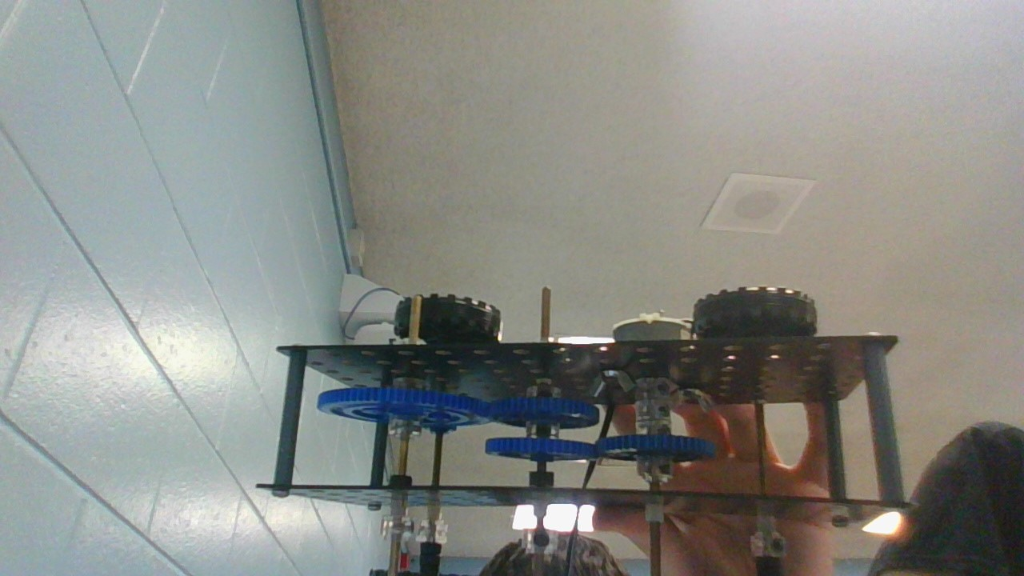
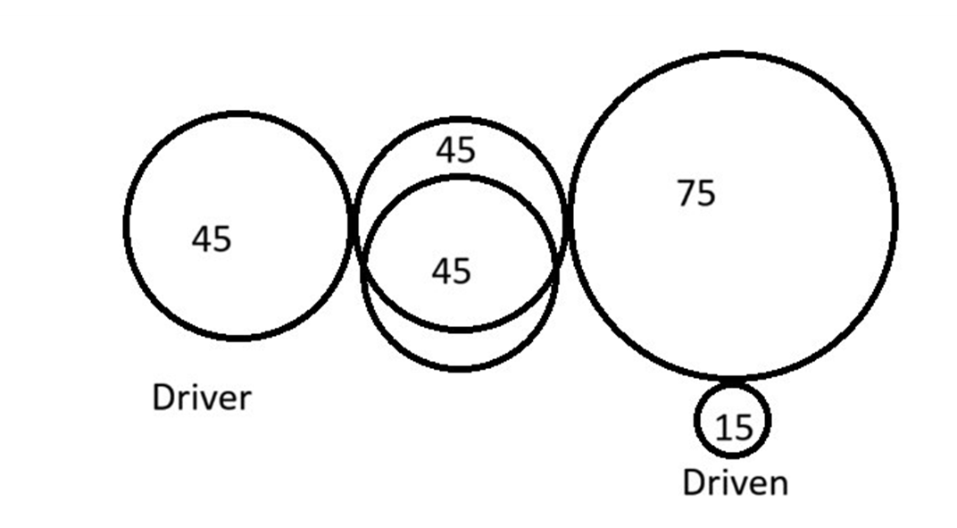
First version: If the Driven is 15 and the Driver is 45 it would be 15/45, but it needs to be simplified: 15 divided by 15= 1, 45 divided by 15= 3. So, the gear ratio would be 1/3, this means the driven gear would turn 3 times faster than the driver gear.
Attempts | Time
1 | Failed
2 | Failed
3 | Failed

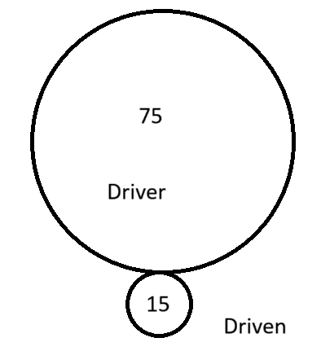
For the second version, I would put the driver to 75 and keep the driven to 15. The gear ratio would be 1/5.

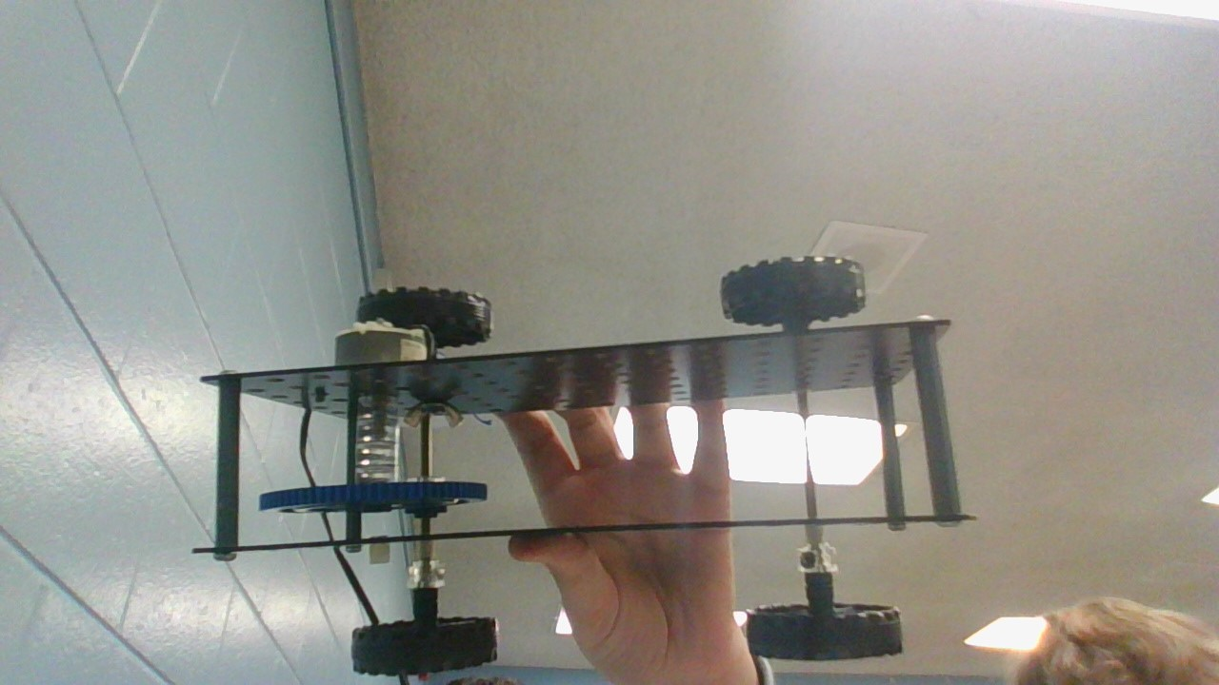

Attempts | Time
1 | Failed
2 | Failed
3 | Failed

For the third version, Gear A is the driver, gear B is on the same axle as C and C is powering D which is the driven.

A and C are both 45, B and D are 15. A to B’s ratio is 1/3, it is the same as C to D’s ratio. To calculate the ratio of all four gears, I would do 1/3 X 1/3, which would give 1/9. Therefore, the gear ratio of the system is 1/9, meaning that the driven gear D will turn 9 times faster than the driver gear A.
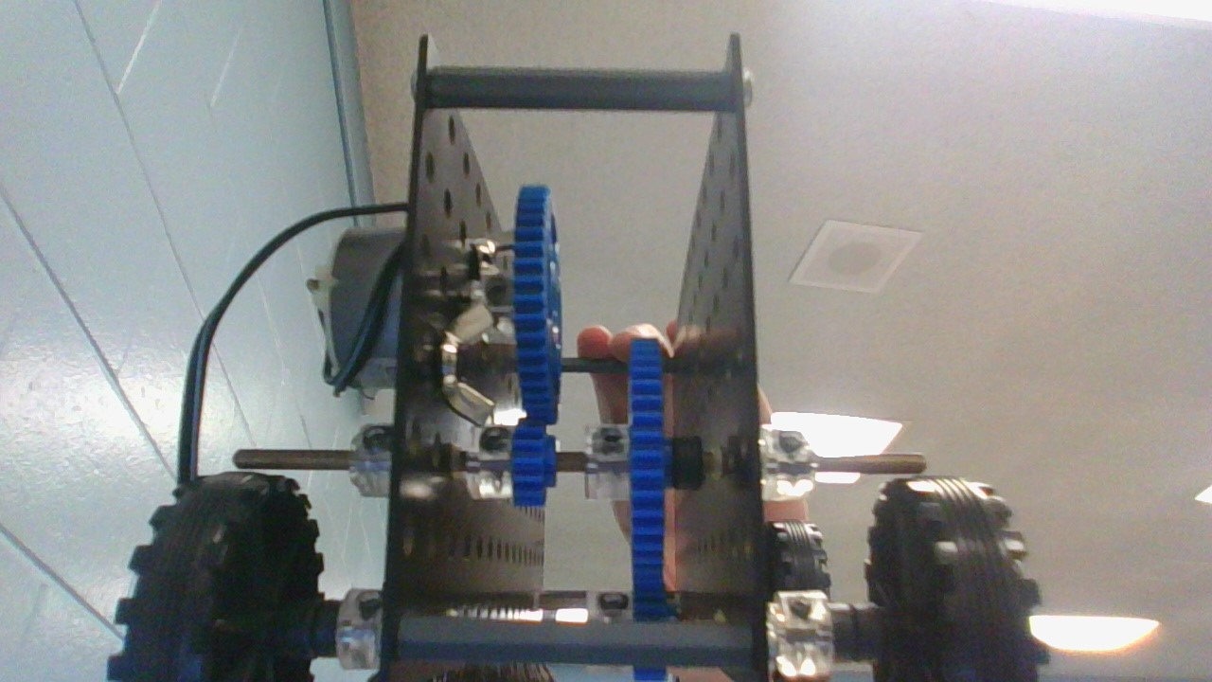
Attempts | Time
1 | Failed
2 | Failed
3 | Failed

Results:
Gear Ratio | Average
1/3 | Failed
1/5 | Failed
1/9 | Failed

